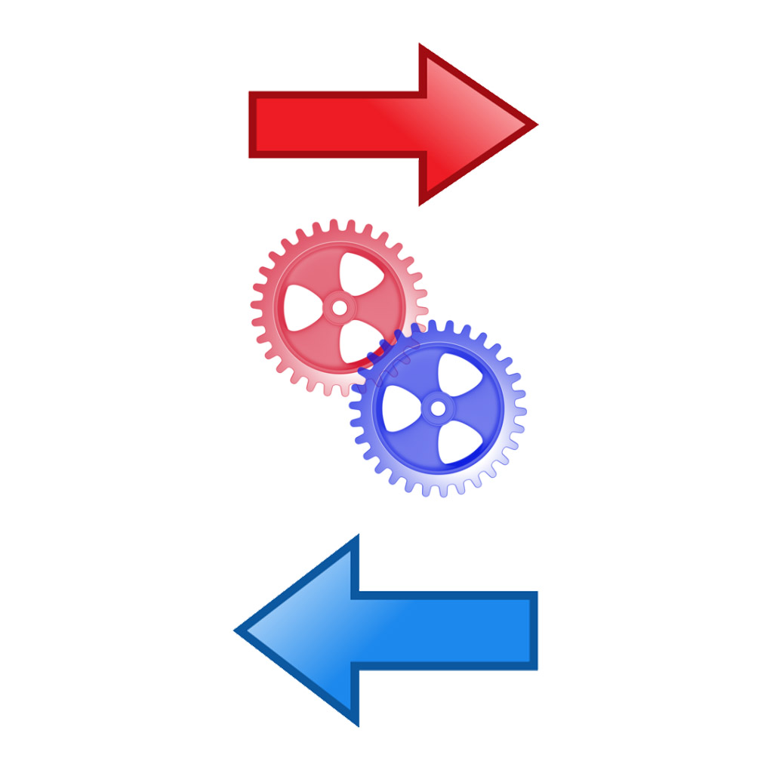

Manual Input of data

Completed

Displayed end results

Correct results given

Search Operation redone

Process defined for wrong input

Decision

Made on input

Search Operation

Data Processed

Start of Function